**MEDIA QUERIES**

Min-width – lower limit

Max-width- upper limit

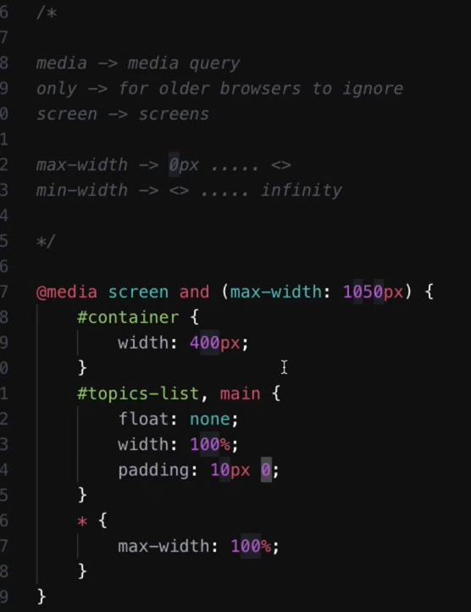

*{

Max-width : 100 % helps every thing on page to take its full width

}

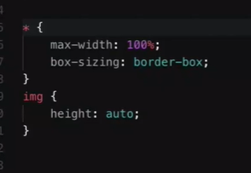

Must do on top avoid extra spacing

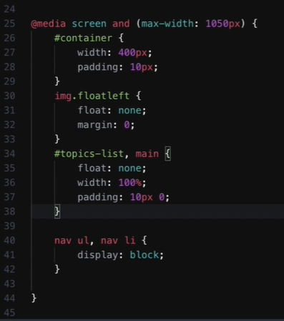

Display block helps a lot in case of ul li tags

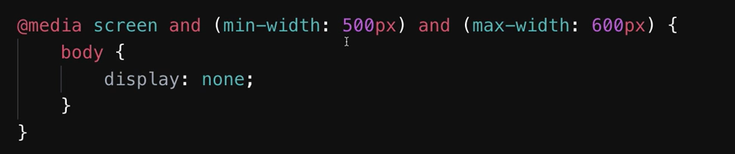

Use Min-width and max-width for a specific range

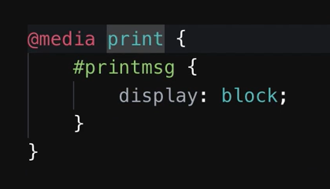

For Print Ctrl+P